**History Handbook**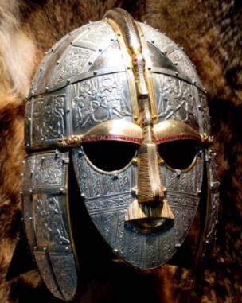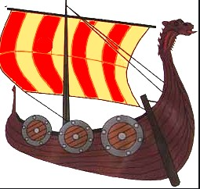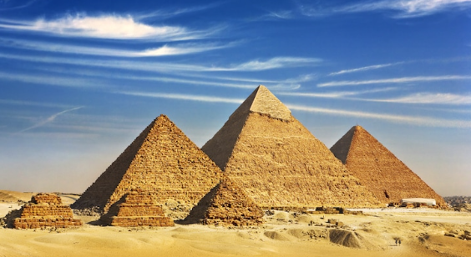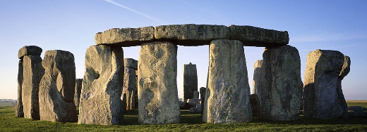

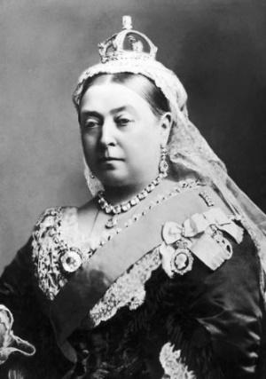

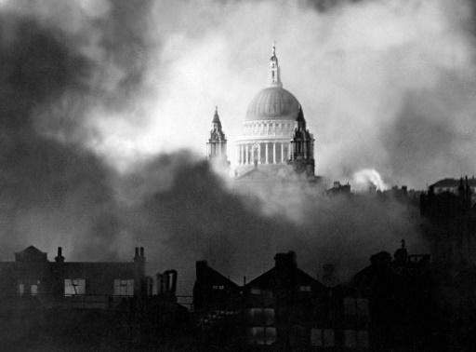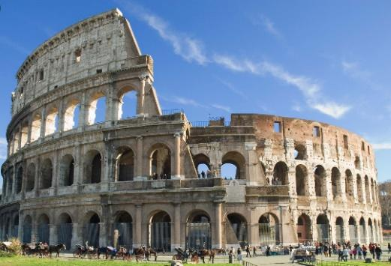

**Contents Page**

Page 3- History Pillars

Page 4 - Grove and Westwood’s Intent for History

Page 5 - Non-Negotiables

Page 6-7 – Long term plan

Page 8-9 – Concept plan

Page 10-11 - Assessment

Page 12 – Useful websites

**History Pillars**

History lessons are underpinned by our History pillars in order to not only provide children with knowledge but also develop historical skills, allowing them to know more and do more, and encourage children to work as historians. History units are planned to ensure that lessons are built upon the key ideas in the History pillars and units always work towards children developing this knowledge and skills.

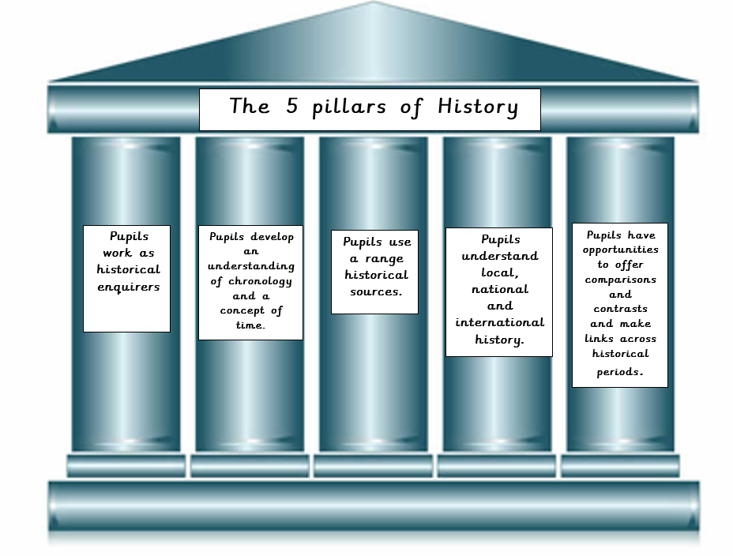

**Grove and Westwood’s Intent for History**

We believe that a well-rounded History curriculum will allow children to gain a coherent knowledge and understanding of Britain’s past and that of the wider world. The learning in History begins in the EYFS and these skills and knowledge are built upon as they progress through the school. The children celebrate the rich history of the local area as well as explore national and global history. Our children will investigate and pose historical questions. We intend for our children to have real life experiences and learn about History in an active and creative way and therefore visitors and trips form a fundamental part of our curriculum. Links to Geography and other subject areas are also explored. In addition to this, we recognise the important role that History plays in preparing our children with skills that they can use for life, raising their aspirations, understanding how to be a good and responsible citizen, understanding change and societal development and a context in which to understand themselves and others. This is extremely important for children at Grove Primary in allowing them access to a much wider world.

**Non-Negotiables**

1. Each learning block to have two Learning Objectives. One for the historical context and the other for what historical skill is being taught.

2. DUMTUMS followed. This could be typed or a combination of written and typed – where the date is written and the Learning Objectives typed.

3. Each learning block to have a Skills for Life attached to it.

4. The children are aware that they are in a history class, with a focus on ‘As a historian I can/am …’

5. Children to have a good understanding of historical content, with the ability to recall key facts.

6. There to be a working timeline visible in each phase area – where children will place their work in the correct chronological place.

6. Pupils to be taught the skills required to be a historian – and be aware that they are being taught this skill. Please refer to the 5 pillars of History.

7. History lessons to be feature a range of activities that include kinaesthetic, visual and auditory learning.

8. Pupils encouraged to be inquisitive learnings who will enjoy their own learning journey.

**Long Term Plan**

|  |  |  |  |  |  |  |
| --- | --- | --- | --- | --- | --- | --- |
|  | **Cycle A** | | | **Cycle B** | | |
| **Year 1/2** | **What was life like when our grandparents were children?** | **How have holidays changed over time?** | **How have inventions impacted our world?** | **Did the Great Fire make London a better or worse place?** | **Mary Seacole and Florence Nightingale: Why should we remember these key figures?** | **What does music mean to Suffolk?** |
| National Curriculum | Changes within living memory | Changes within living memory | Events beyond living memory that are significant nationally or globally. | Events beyond living memory that are significant nationally or globally. | Significant people. | Changes within living memory |
| **Year 3/4** | **What was life like for black people in Britain up to 1833?** | **How has Crime and Punishment**  **changed over time?** | **What happened when the Romans**  **came to Britain?** | **How much did the Ancient Egyptians achieve?** | **What was new about the New Stone Age?** | **Was life peaceful or violent during the Bronze and Iron Age** |
| National Curriculum | A local history study.  Significant people. | A study of an aspect British history that extends pupils’ chronological  knowledge beyond 1066. | Changes in Britain. | The achievements of the earliest civilizations. | Changes in Britain. | |
| **Year 5/6** | **Did WWI or WWII have the biggest**  **impact on our locality?** | **How were the journeys of the Kindertransport and the Windrush similar and different?** | **Ancient Greeks - what did the Greeks do for us?** | **The Anglo-Saxons and The Vikings -**  **Vicious warriors or peaceful settlers?** | | **How do the civilisations of the Mayan and the Vikings differ?** |
| National Curriculum | A local history study. |  | A study of Greek life and achievements and their influence on the  western world. | Settlement.  The struggle for the Kingdom of England to the time of Edward the Confessor. | | A non-European society that provides contrasts with British history |

**Key Concept plan**

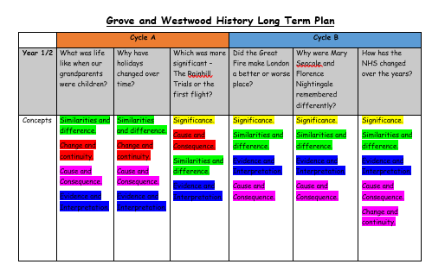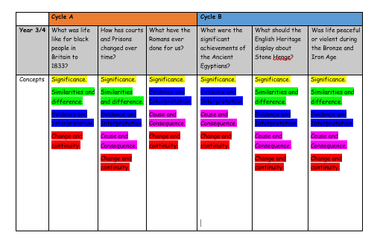

|  |
| --- |
|  |

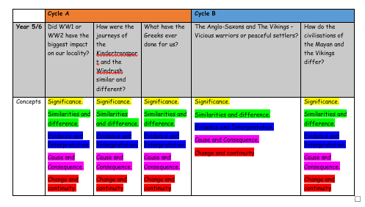

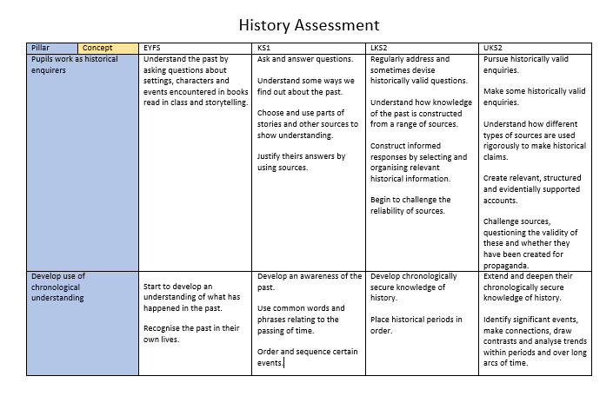

**Holidays – Knowledge Organiser**

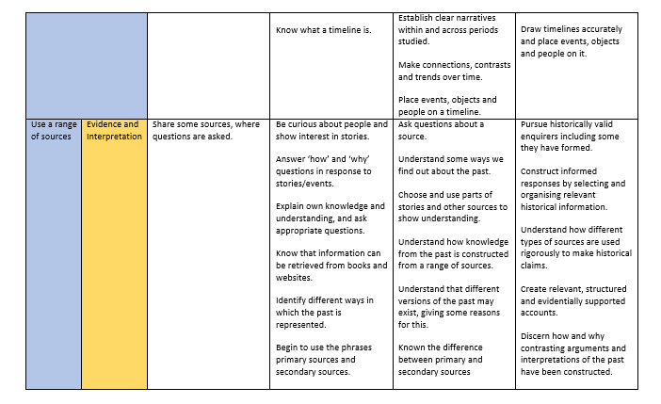

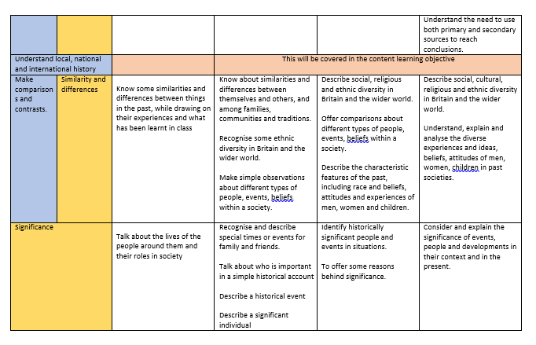

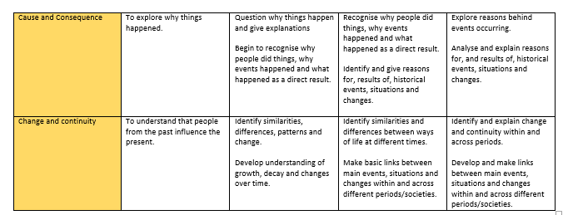

**Useful websites:**

Historical Association - <https://www.history.org.uk/>

<https://www.bbc.co.uk/bitesize/subjects/zcw76sg>

Key Stage 2 - <https://www.ks2history.com/>

<http://teachinghistory100.org/>

<https://www.keystagehistory.co.uk/primary-history/> - Need to subscribe

<https://www.teachitprimary.co.uk/history>

<https://www.educationquizzes.com/ks1/history/> - KS1 and KS2 quizzes

<https://www.webanywhere.co.uk/education/teaching-resources/primary/history>

<https://www.theschoolrun.com/>